

**ASSIGNMENT NO.1**

**COURSE**

**CASE2163 : WEB PROGRAMMING**

**TOPIC**

TODOAPP -BACKEND ONLY

**SUBMITTED TO:**

PROF. HAMZA AFZAL

**SUBMITTED BY**

NAME : LAIBA KHAN

ROLL NO. : 229

SECTION : D

**BSCS(2022-2026)**

**SUBMITTED ON:**

MAY 9, 2025

**SUMMARY:**

For this assignment, a backend-only To-Do List application is developed using Node.js and Express.js. The project focused on understanding how REST APIs work and how they can be tested using Postman. No frontend or database was used—tasks were stored temporarily in a simple array within the server.

**Tasks learned:**

* How to initialize and set up a Node.js project using npm.
* How to use Express.js to create a web server and define API routes.
* The structure of a REST API, including how to implement POST, GET, and DELETE methods.
* How to use Postman to send HTTP requests and test API responses.
* The importance of data structures (like arrays) for temporary storage when no database is used.
* Basics of route parameters and request body parsing using express.json().

**Steps Followed:**

1. **Project Setup:**

* **Development Environment**: The project was implemented and developed using **Visual Studio Code (VS Code)** as the primary code editor
* **First,** created a project folder named (backend).
* Installed and initialized node.js using **npm init -y** in command prompt
* Express.js was installed using **npm install express**.
* A file **index.js** was created.the methods for post,get and delete were created in this file.

1. **Testing with postman:**

* Index.js was started using command **node server.js.** The project started running on[**http://localhost:3000**](http://localhost:3000)
* Using postman ,the each API route was tested with proper input.
* Developed a **POST /addTask** route to add new tasks with unique IDs.

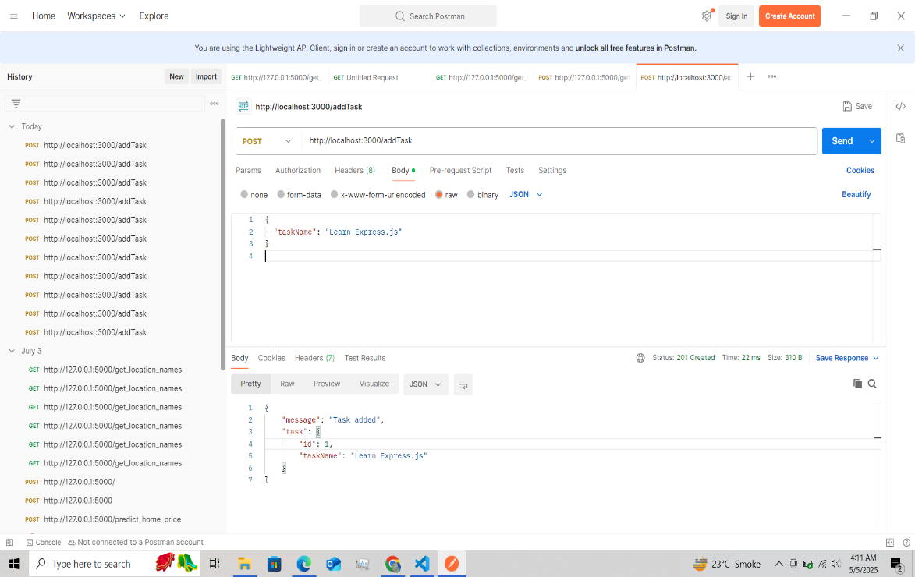

* Created a **GET /tasks** route to retrieve all current tasks.

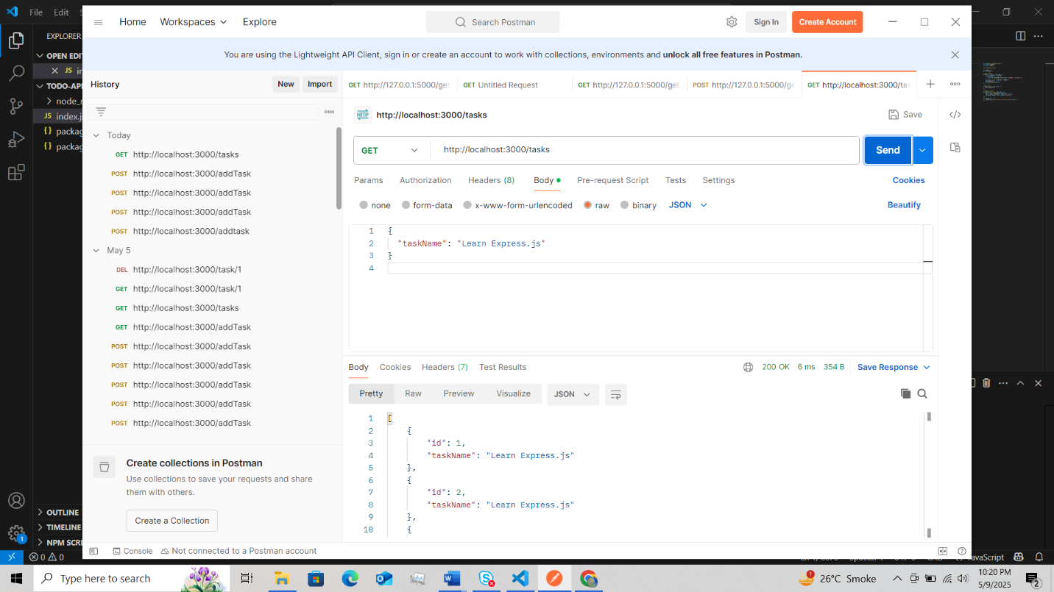

* Implemented a **DELETE /task/:id** route to remove a task by its ID**.**

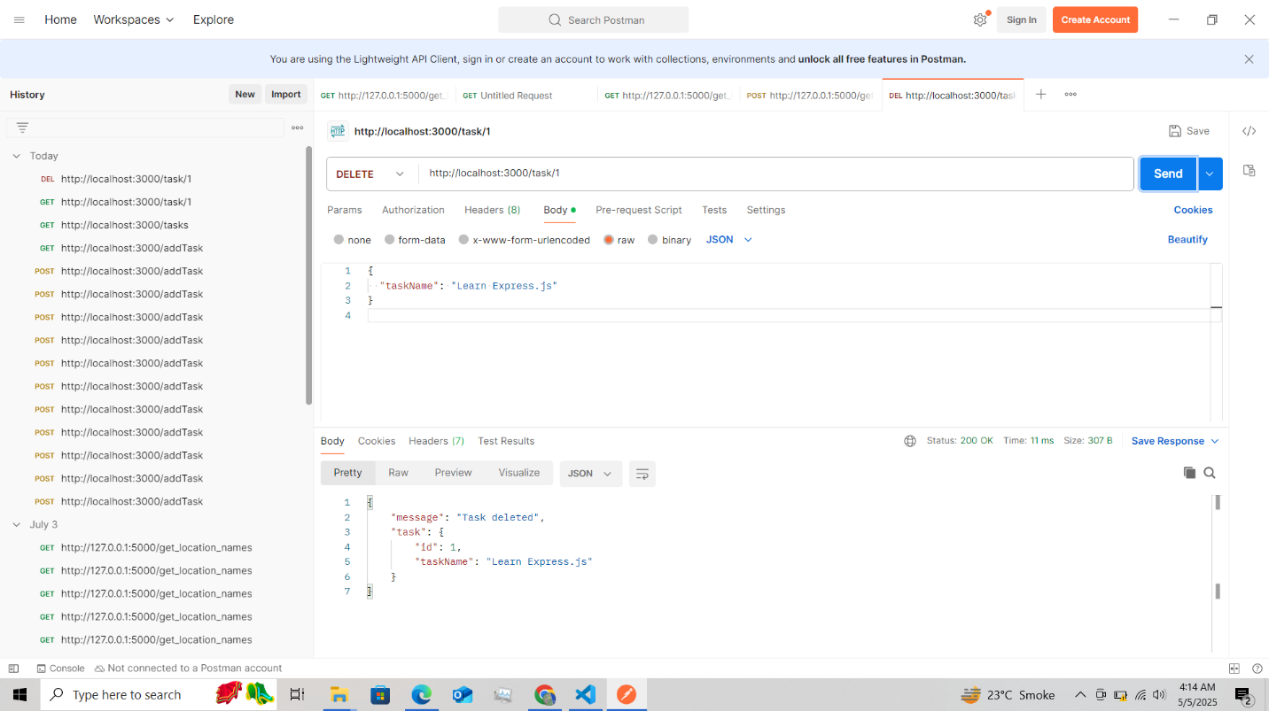

1. **Code Management: Uploaded the full project to GitHub as required.**